# Calculate & Plot the Composite Index

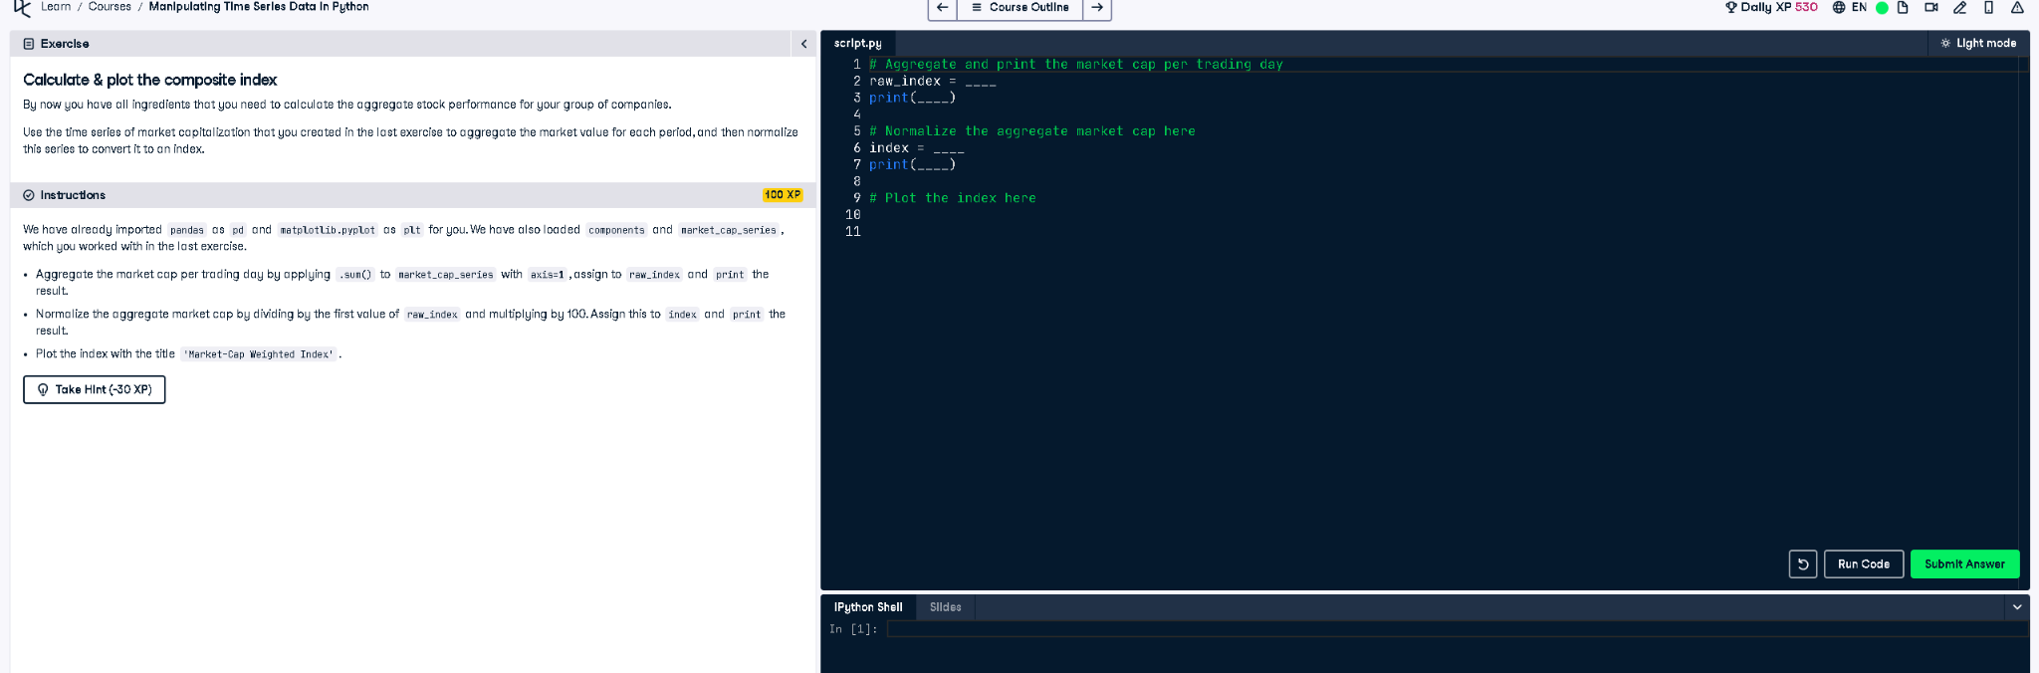

## Final Code

# Aggregate and print the market cap per trading day  
raw_index = market_cap_series.sum(axis=1)  
print(raw_index)  
  
# Normalize the aggregate market cap here  
index = raw_index / raw_index.iloc[0] * 100  
print(index)  
  
# Plot the index here  
index.plot(title='Market-Cap Weighted Index')  
plt.show()

## Explanation

This code calculates a market-cap weighted index over time. First, it sums the market cap of all stocks per day, then normalizes by the first day's value and scales it to 100. Finally, it plots the index to visualize trends.